
The main focus of our green schools committee this year has been to:

... and WE DID IT!
We can officially confirm that Old Bawn Community School has been awarded with their 3rd green flag for water conservation.
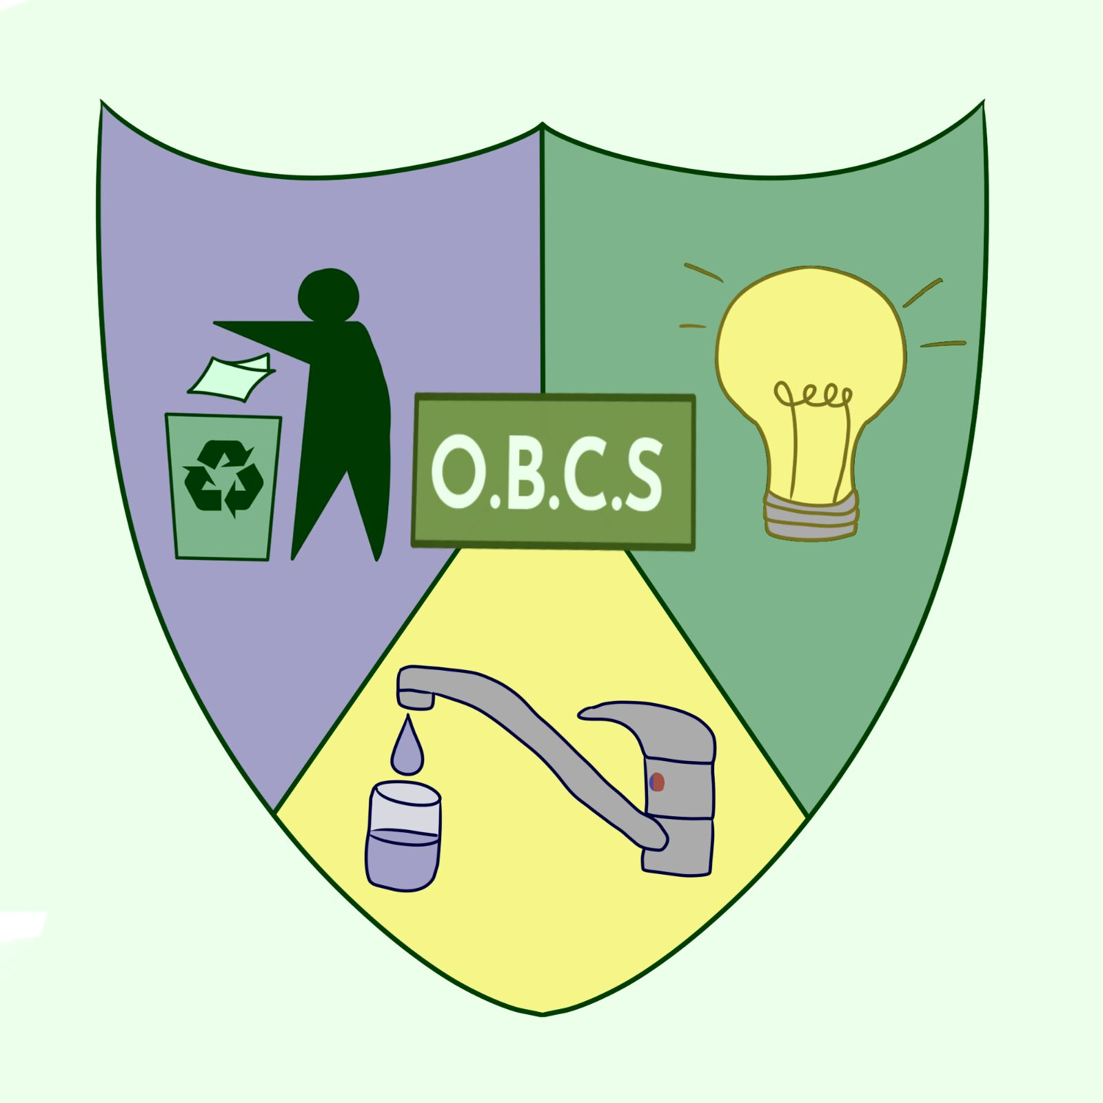
Our beautiful new green schools crest was created by the very skilled Grace Lynch, Thank you for all your hard work on the green team!
The images below capture some of the hard work carried out by our committed team. We would like to thank the whole school body and wider community for all their support and assistance helping us on our way to achieving our water flag.
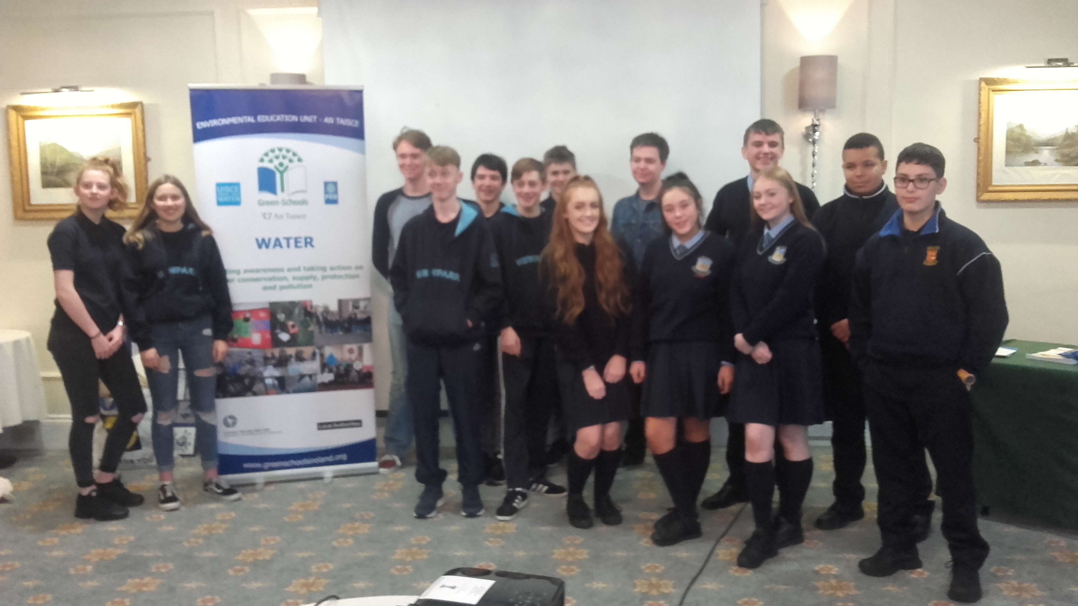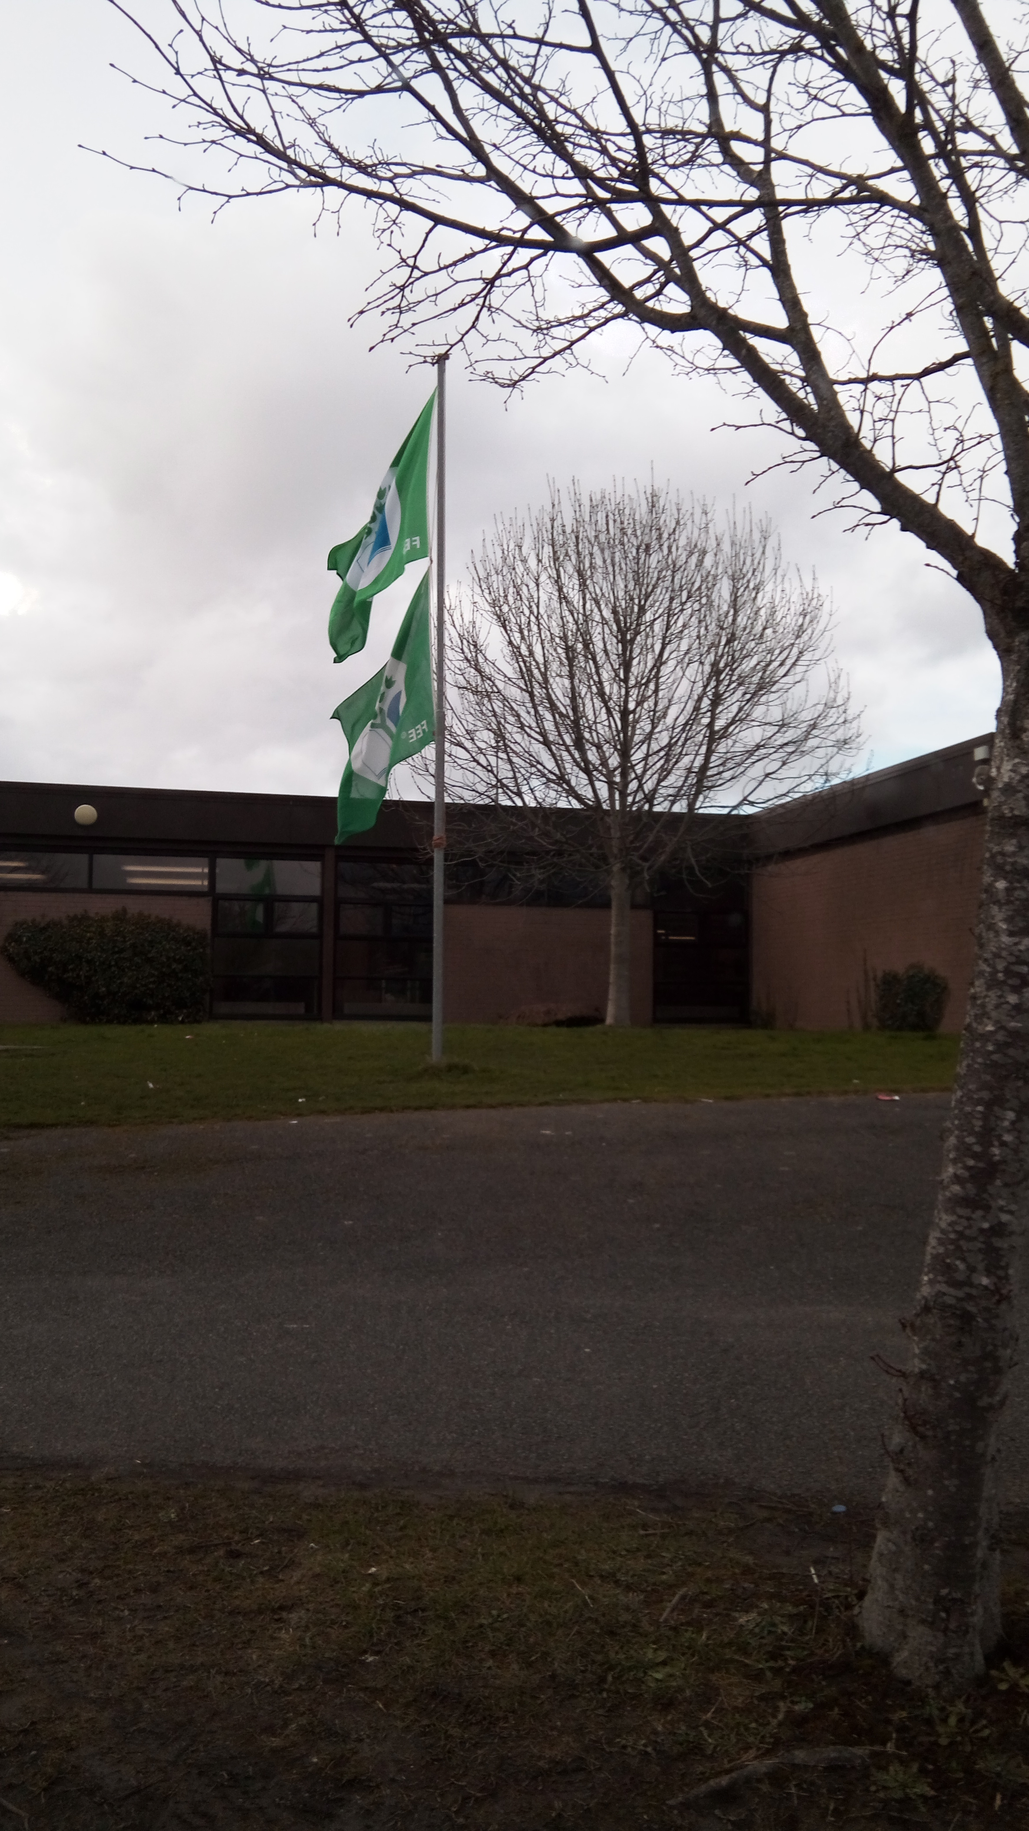
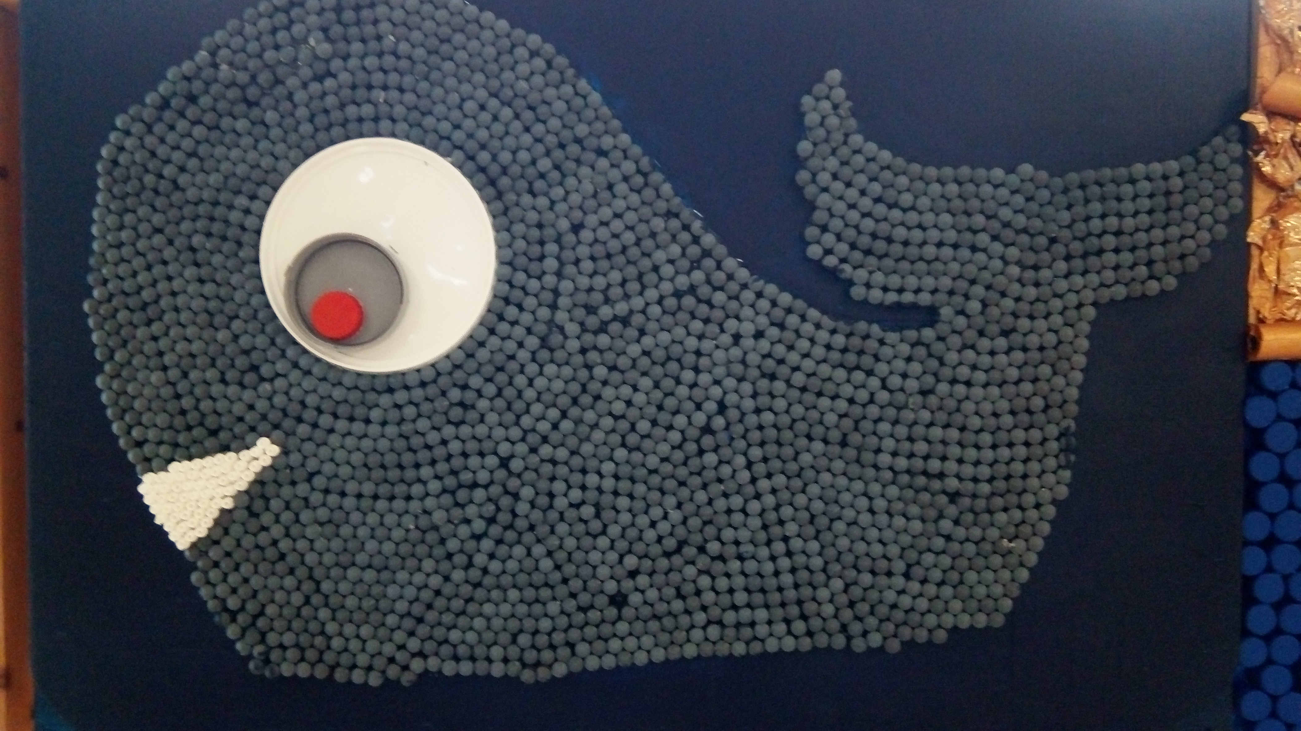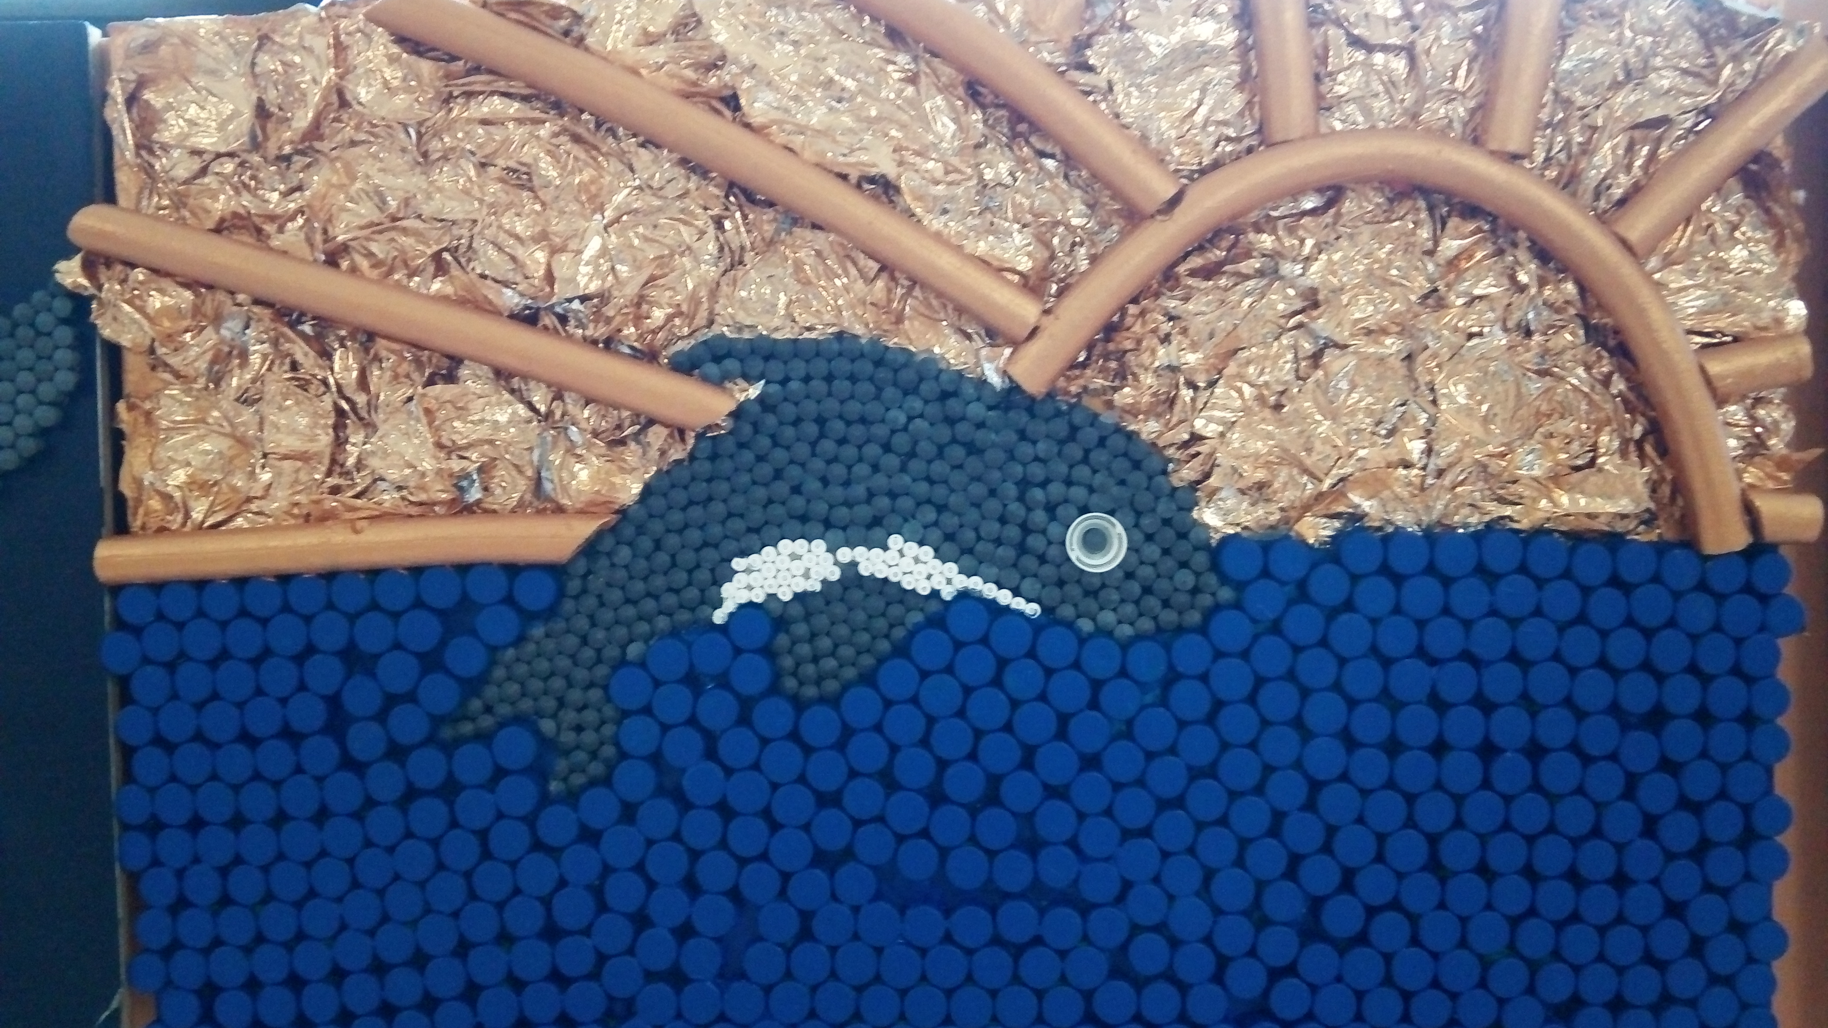
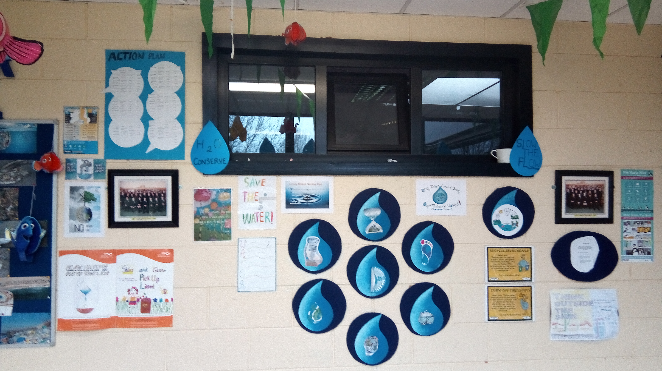
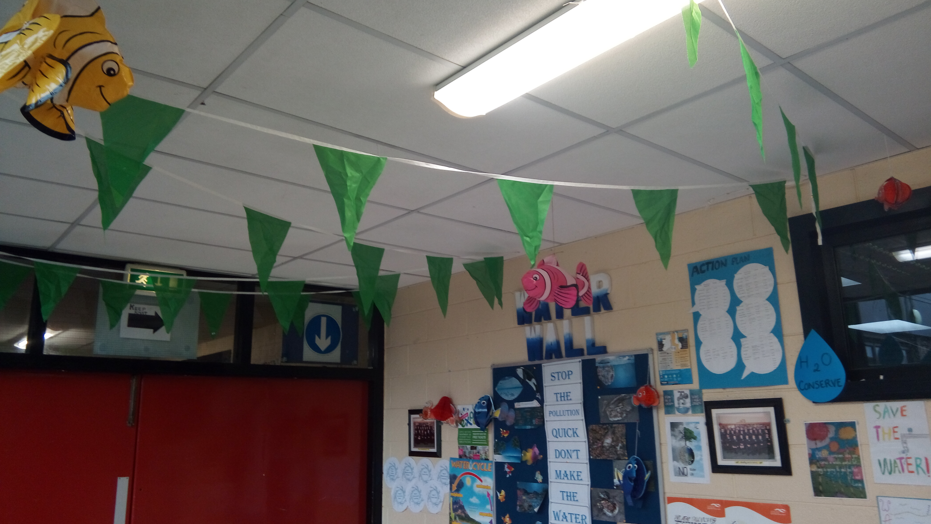
Our green team have strived to display their skills and talents through various competitions this year.

We are thrilled to announce that, Saoirse Laird (TY student) won not 1, but 2 competitions.
- Green schools art competition – senior sector
- Young reporter for the environment – senior sector
She has been awarded fantastic prizes including a tablet. This is just the beginning for Saoirse… a huge well done!
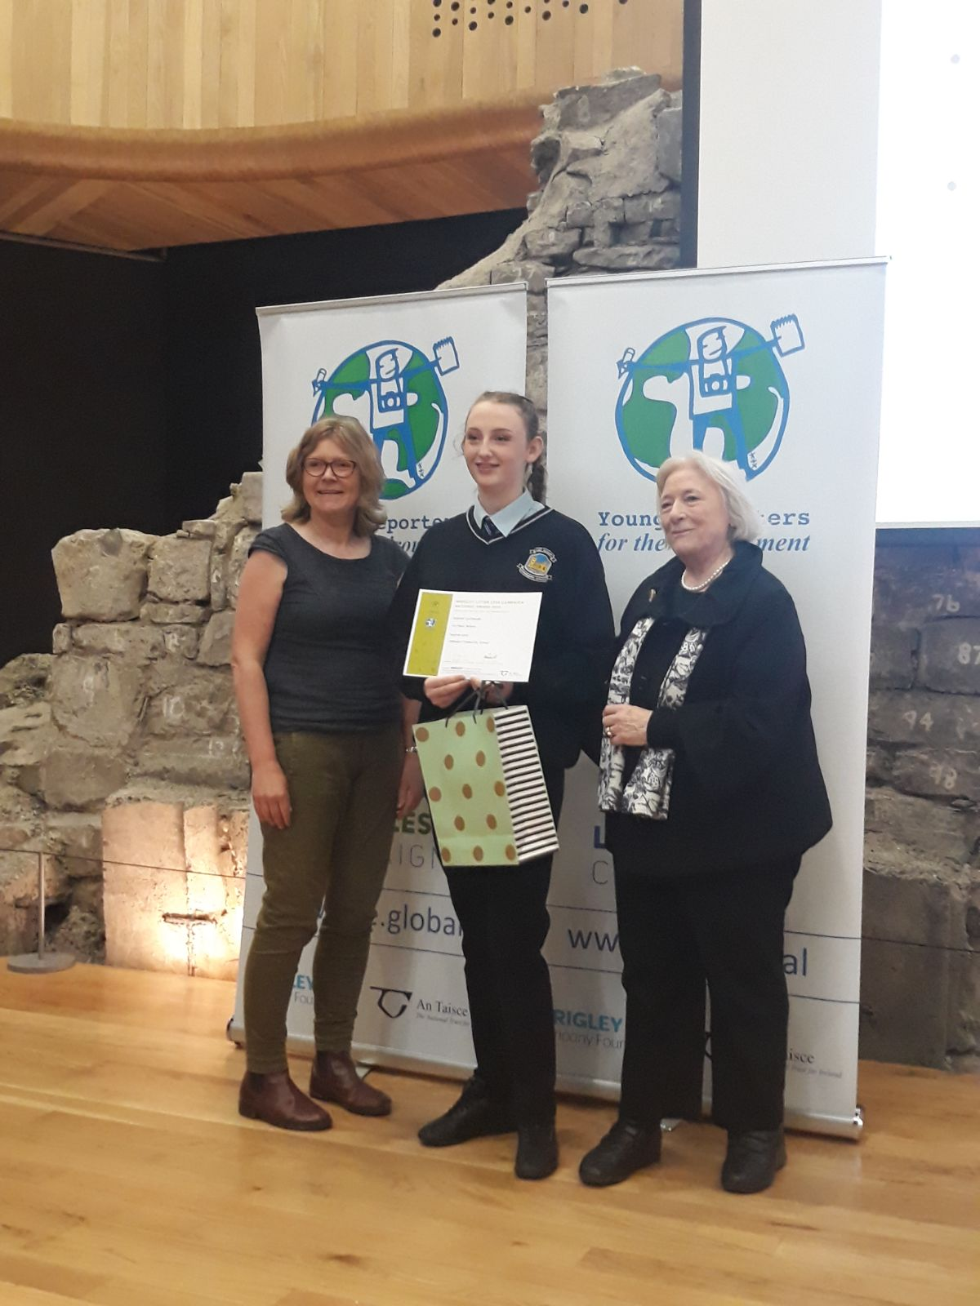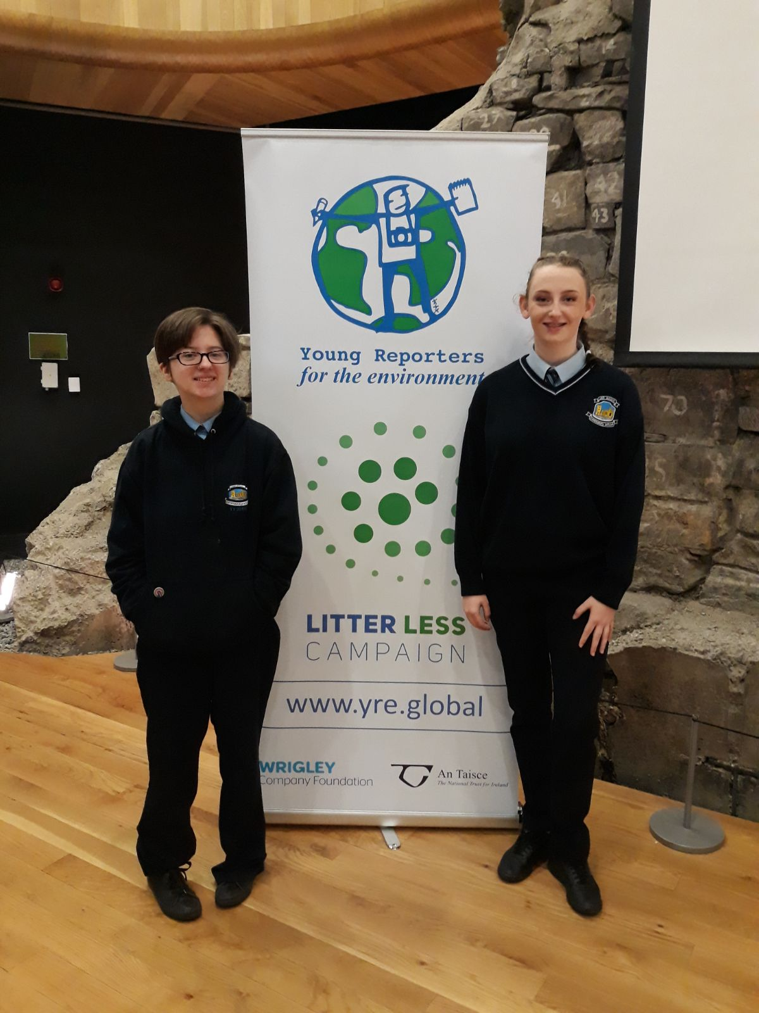
A Green Day of celebrations will soon be taking place, once again a huge thank you to every student, teacher, parent and member of the community as well as green schools themselves who contributed to our success!

