How to make a payment online for YOUR SCHOOl tour
Visit www.gti-ireland.com/payment
Select the Private Groups / School Tours option
You will be asked for the following information:
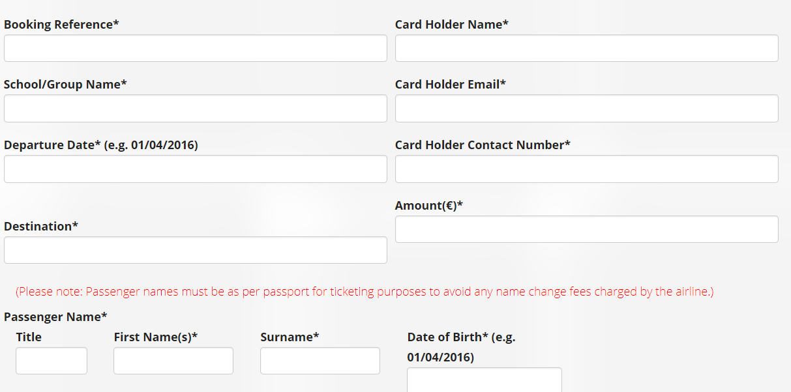
- Booking Reference: 19-OBC001-01/Surname
- Departure Date 13/April/2019
- Destination Paris
- Amount 250
Click confirm; you will be taken to a summary page to check the details you entered
If you are happy with the details, you can continue to the Realex page, a secure payment website to enter your card details & make payment
You will then receive a confirmation number on screen, followed by an email which you can show to your Group Leader as proof of payment

