How to make a payment online for YOUR SCHOOl tour TO Krakow
- Visit www.gtitravel.ie/make-a-payment/ where you will be prompted to either register if it’s your first visit or log in for subsequent visits.
An account is automatically created for you on your first visit. A password is sent to the email address you entered. You will need this password for your next log-in and to check the payments made for your child’s tour.
- Select the Make a Payment option under School Tours
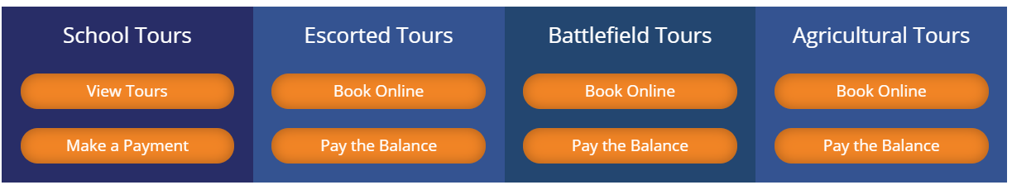
- You’ll then be asked for the Tour Details which for your school are as follows:
Tour Details
____________________________________________________________________________________________
Booking Reference * School/ Group Name *
20-OBC001-01/Your Child’s Surname
Old Bawn CS
Departure Date * Destination *
03-04-2020
Krakow
- You’ll then be asked for the Passenger Details which are specific to your child. The Date Format for DOB must be DD-MM-YYYY.
- Click Continue to Payment where you will be taken to the secure payment page. Enter the deposit amount along with your card details. The deposit of €250 is non-refundable.
- Click Pay Now. Don’t forget to tick the T&C box.
Once the payment is gone through, a Payment Reference Number will appear on the screen. This is the number that your teacher will need as proof of payment. An email will also be sent to you.

